Task CW and CT
- Enable CloudTrail monitoring and store the events in S3 and CloudWatch log events.
Step 1: Create S3 Bucket for CloudTrail Logs
1. Go to S3
2. Click Create bucket
3. Bucket name: my-cloudtrail-logs-123
4. Keep default settings
5. Create bucket
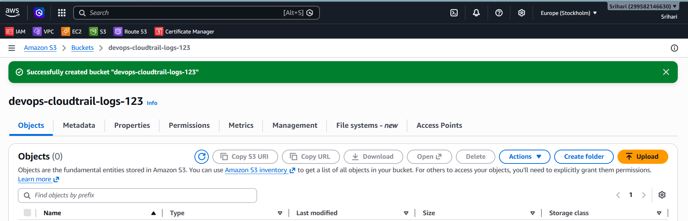
Step 2: Create CloudWatch Log Group
1. Go to CloudWatch
2. Logs → Log groups a Logs Management
3. Create log group
4. Name: CloudTrail-Logs
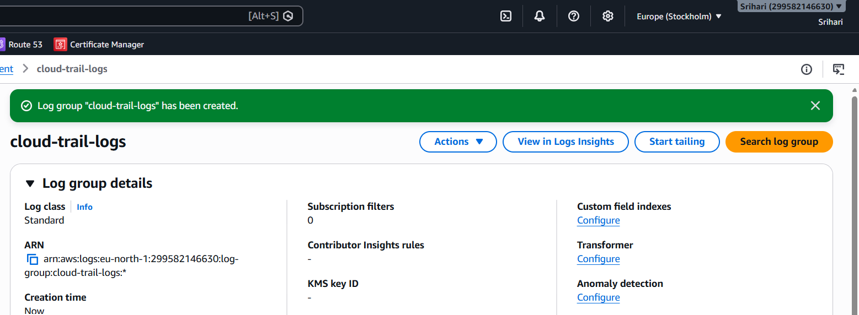

Step 3: Create Trail
1. Go to CloudTrail
2. Click Create trail
3. Trail name: MyTrail
4. Storage location:
Choose existing S3 bucket
Select your bucket
5. Enable CloudWatch Logs
Select log group: CloudTrail-Logs
create role: CloudTrail-CloudWatch-Role
6. Choose:
Management events → Read/Write
7. Create trail
Now CloudTrail logs are stored in:
· S3
· CloudWatch Logs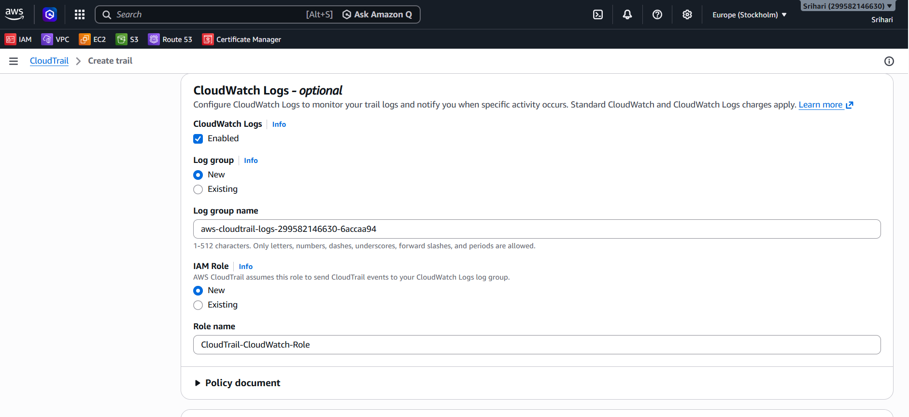
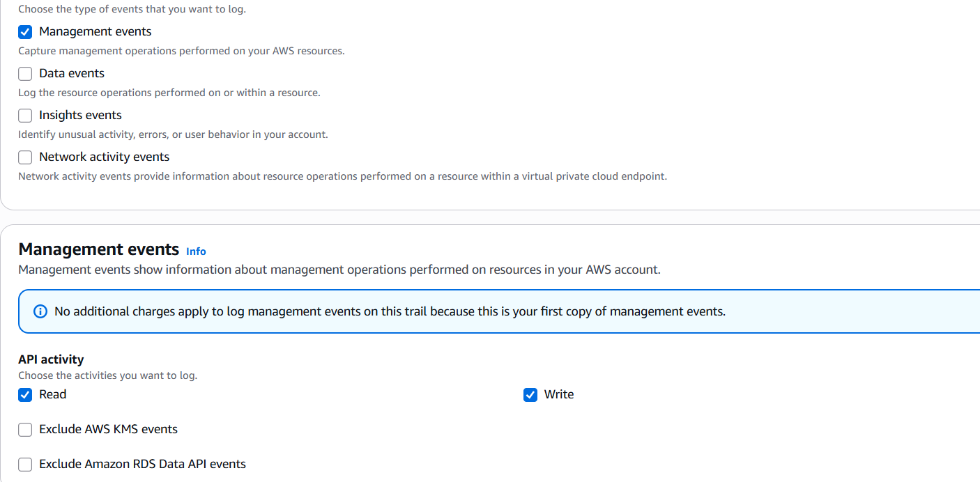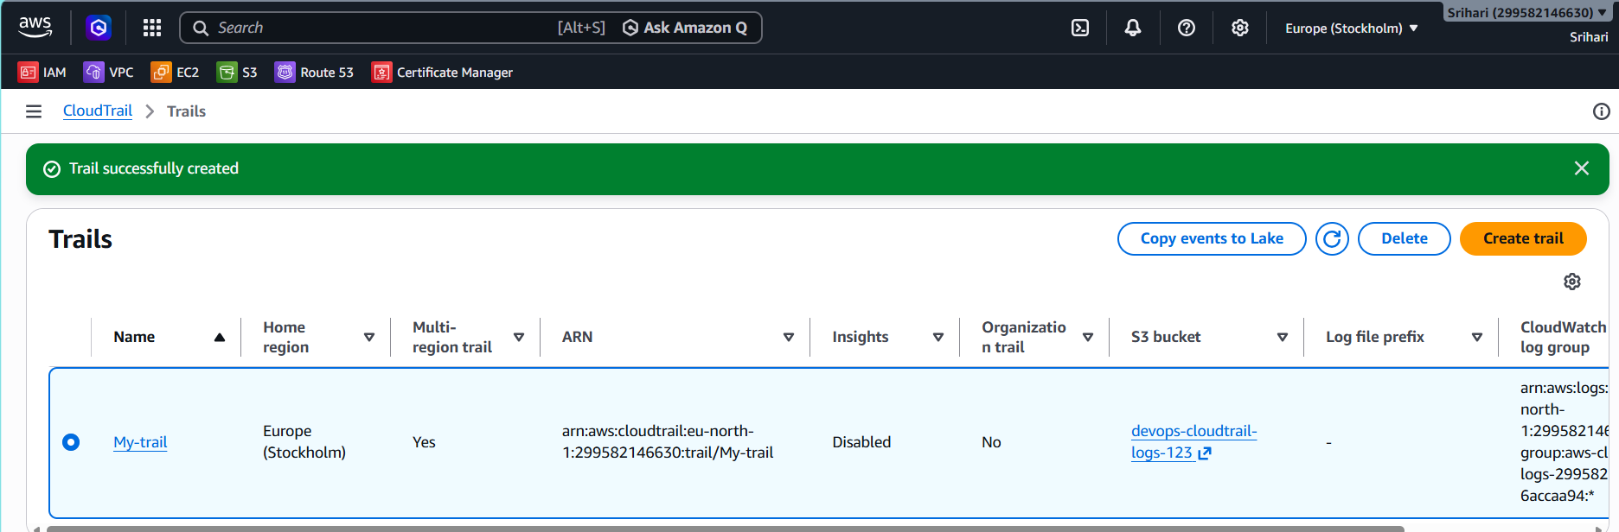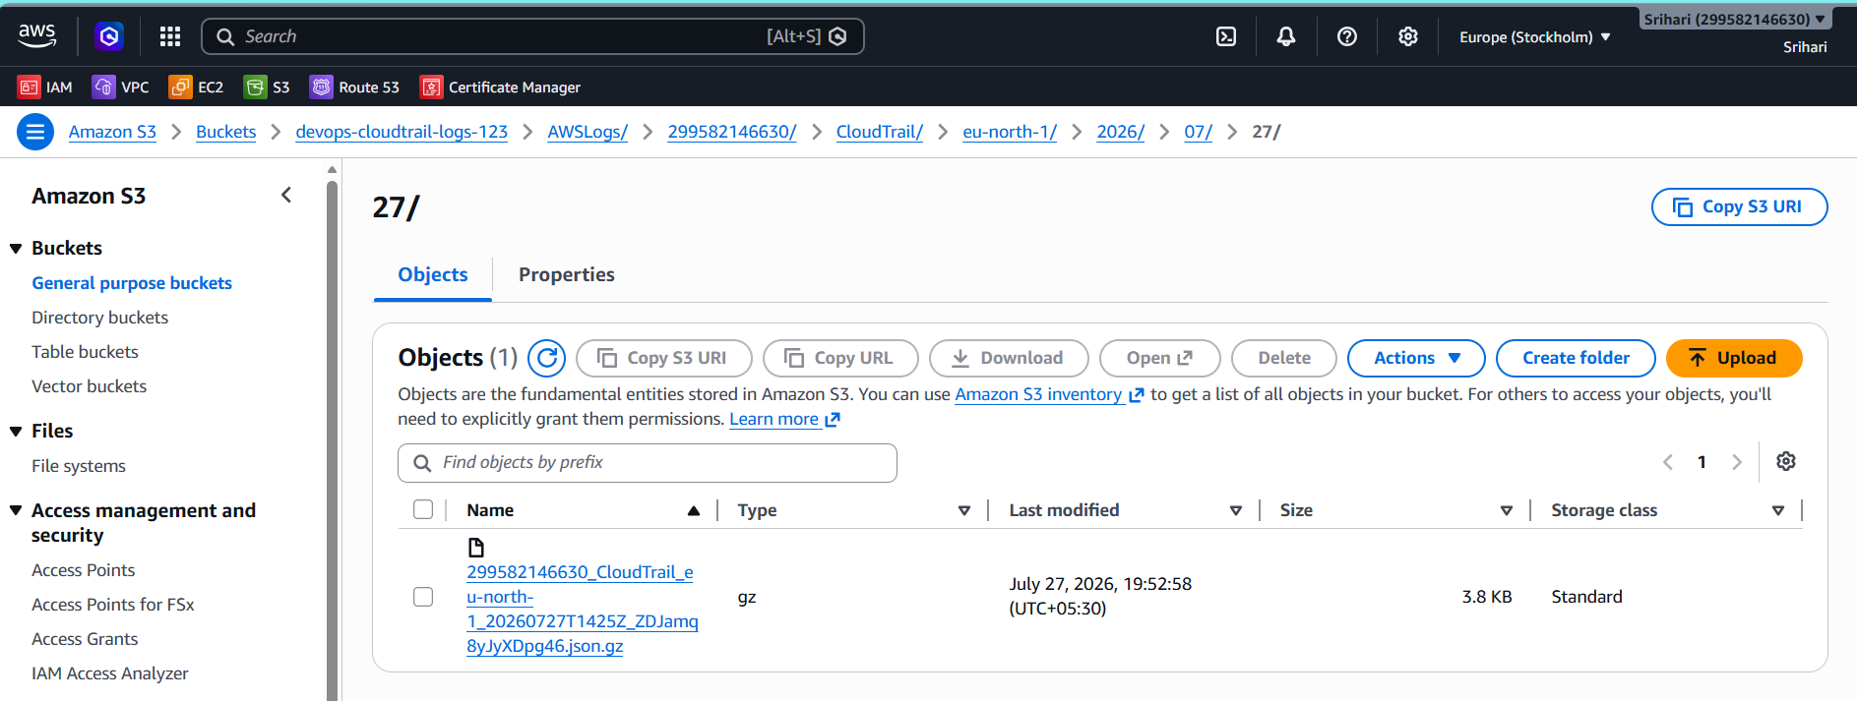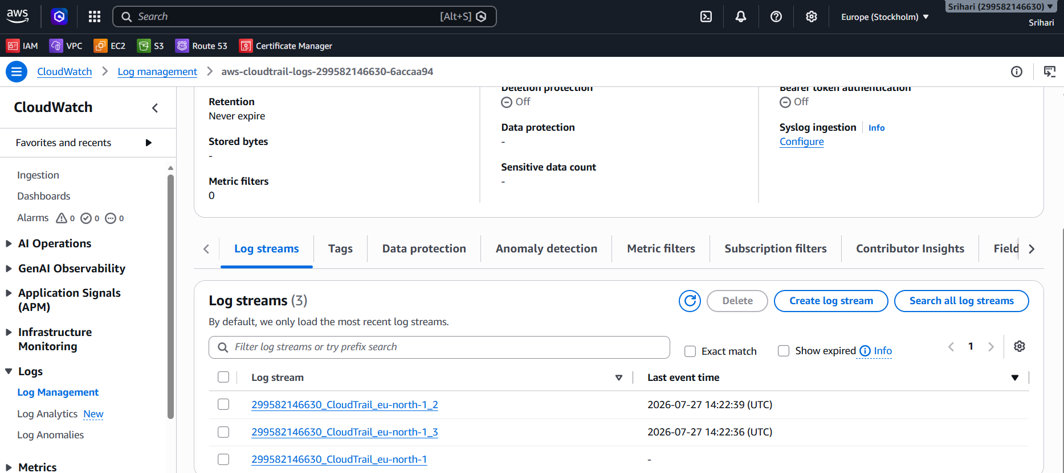

- Enable SNS for CloudTrail to send alerts via email.
Step 1: Create SNS Topic
1. Go to SNS
2. Create topic
3. Type: Standard
4. Name: CloudTrail-Alerts
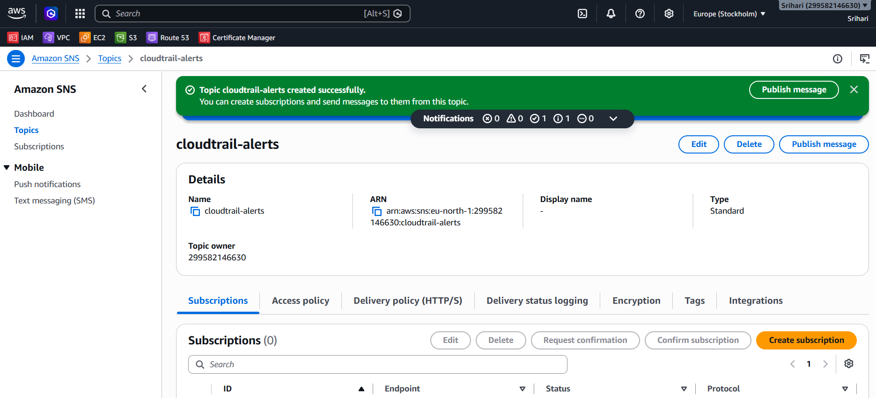Step 2: Add Email Subscription
1. Open topic
2. Click Create subscription
3. Protocol: Email
4. Enter your email
5. Confirm email from inbox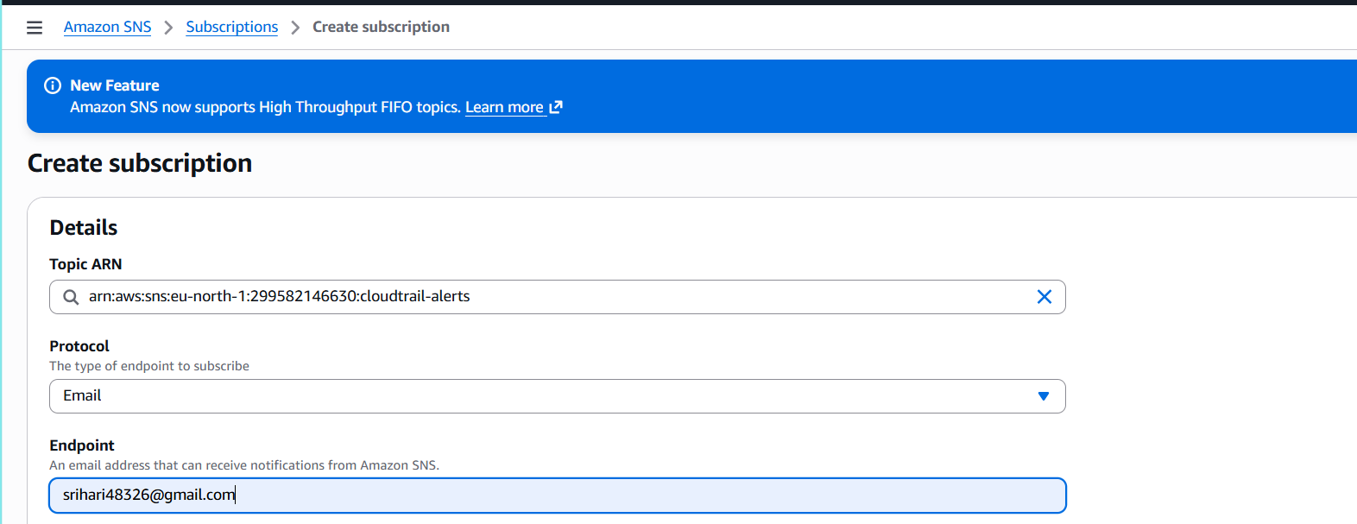
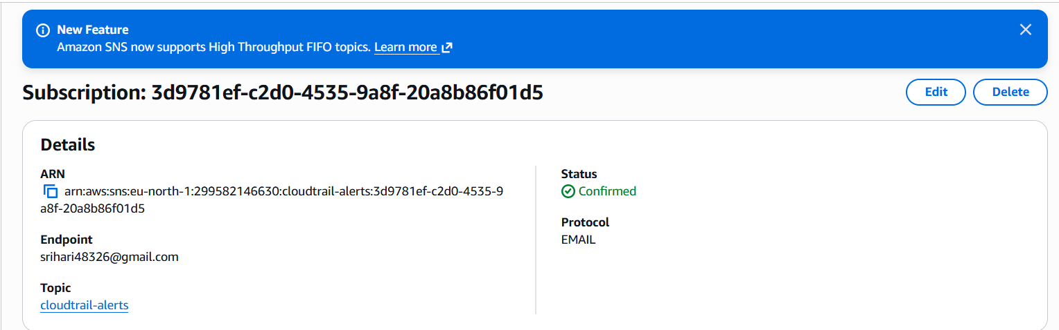

- Configure CloudWatch monitoring and record the CPU utilization and other metrics of EC2.

Step 1: Launch an EC2 Instance
- Log in to the AWS Management Console.
- Go to EC2.
- Launch an EC2 instance (Amazon Linux).
- Ensure the instance is in the Running state.
- Enable:
  - Detailed Monitoring ✔
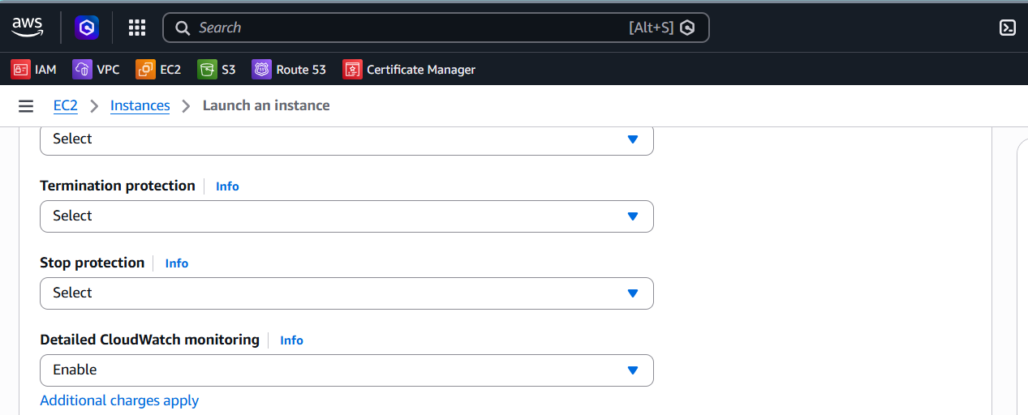
Step 2: Open CloudWatch
- Search for CloudWatch in the AWS Console.
- Open the CloudWatch service.

Step 3: View EC2 Metrics
- In the left panel, click Metrics.
- Click All metrics.
- Select EC2.
- Click Per-Instance Metrics.
- Select your EC2 Instance ID.
You will see metrics such as:
- CPUUtilization
- NetworkIn 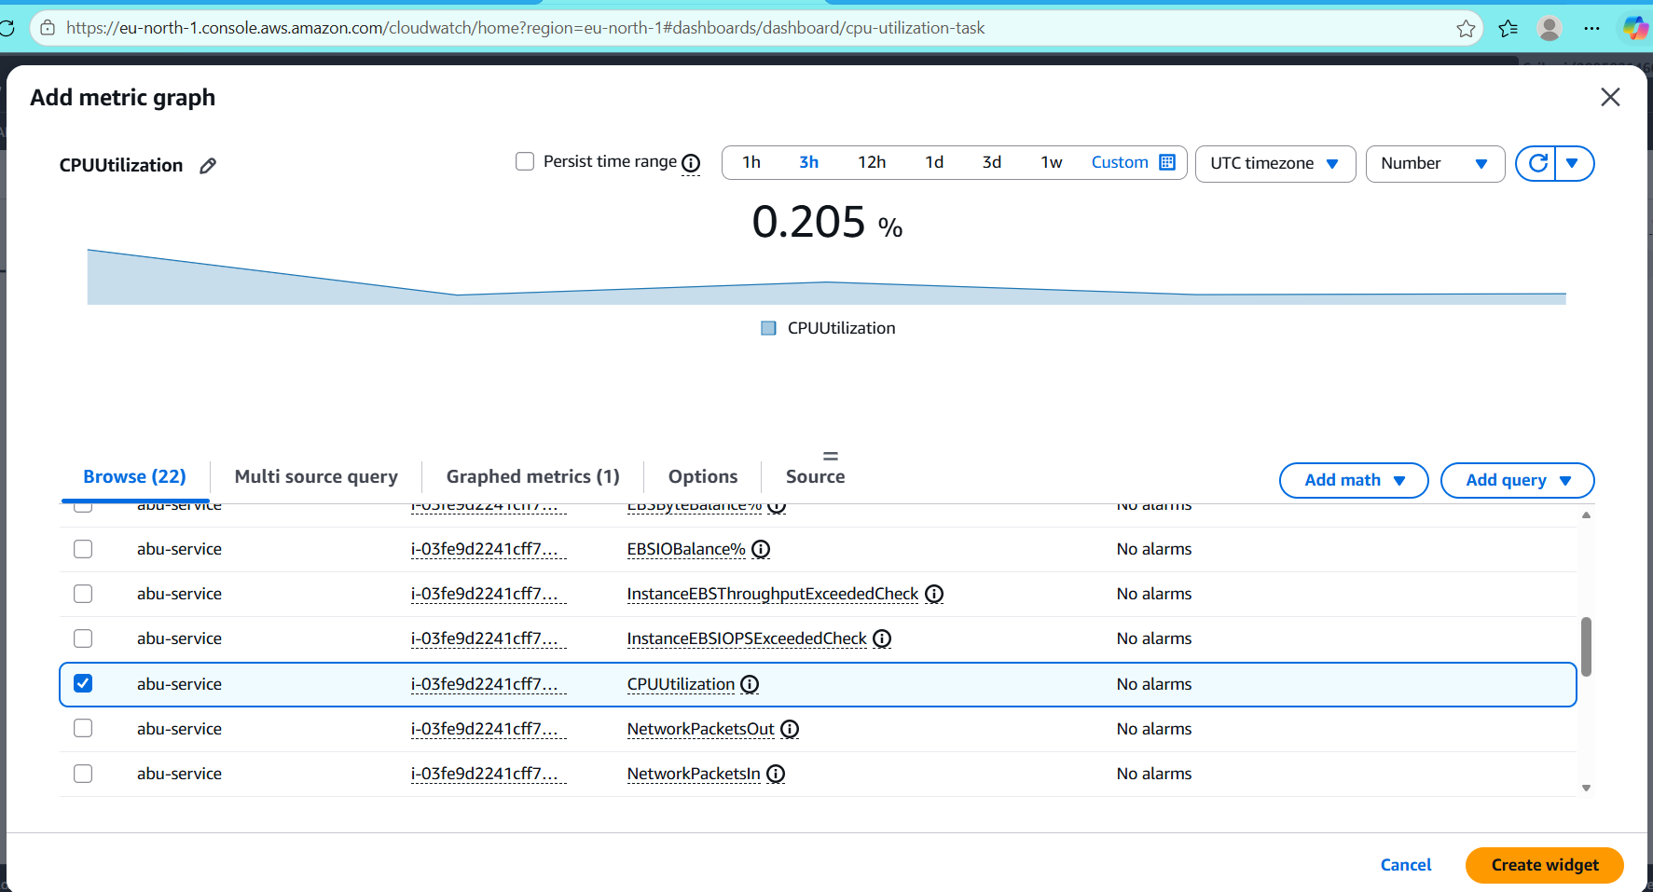
Add a CloudWatch Dashboard Widget
- Open the CloudWatch console.
- In the left menu, click Dashboards.
- Click Create dashboard.
- Enter a dashboard name and click Create dashboard.
- Click Add widget.
- Select Line (or another chart type) and click Next.
- Choose:
  - EC2
  - Per-Instance Metrics

- Select the metrics you want, such as:
  - CPUUtilization
  - NetworkIn
- Click Create widget.
- Click Save dashboard.
Step 4: View CPU Utilization
- Click CPUUtilization.
- A graph showing CPU usage will appear.
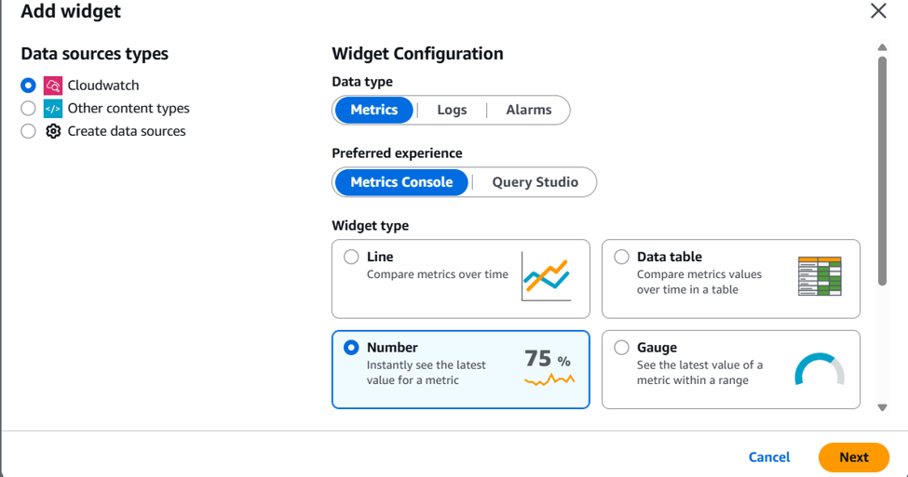
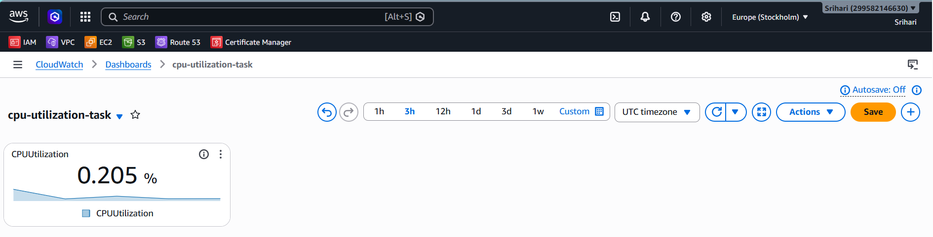

- Create one alarm to send an alert to email if the CPU utilization is more than 70 percent.
Go to:
CloudWatch → Alarms
1. Create alarm
2. Select metric
3. EC2 → Per-Instance Metrics
4. Choose: CPUUtilization
5. Condition:
Threshold type: Static
Greater than: 70
6. Period: 5 minutes
7. Select SNS topic: CloudTrail-Alerts
8. Name:
EC2-High-CPU-Alarm
Email will trigger if CPU > 70%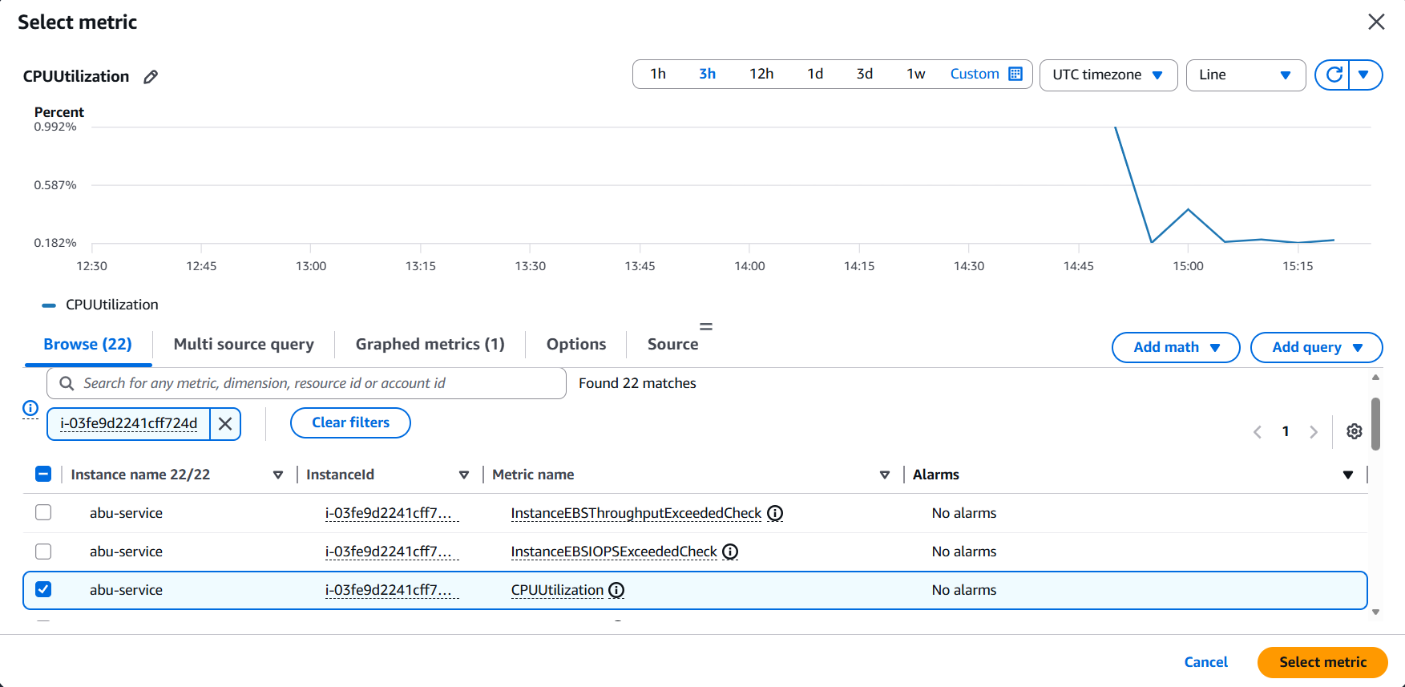
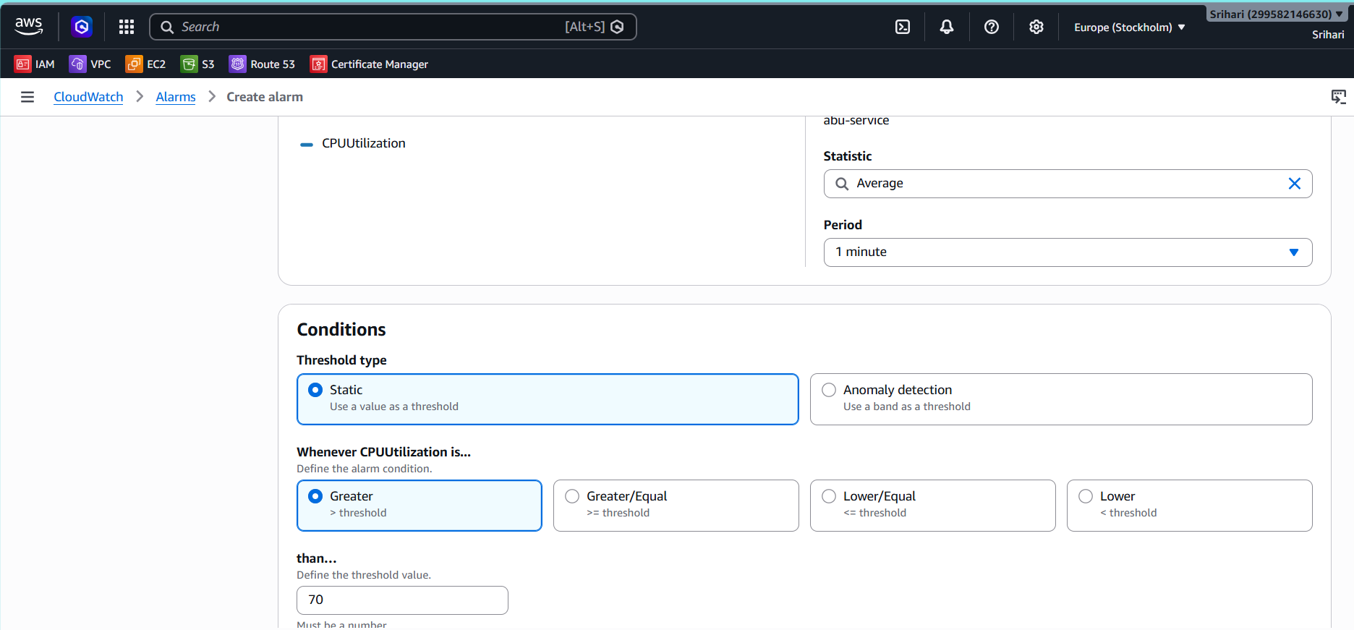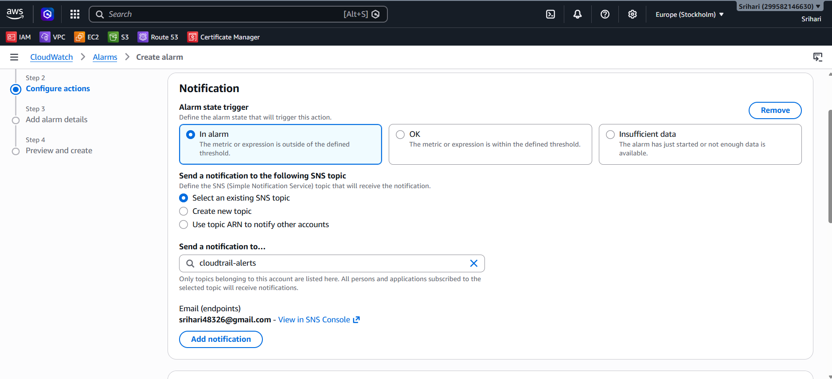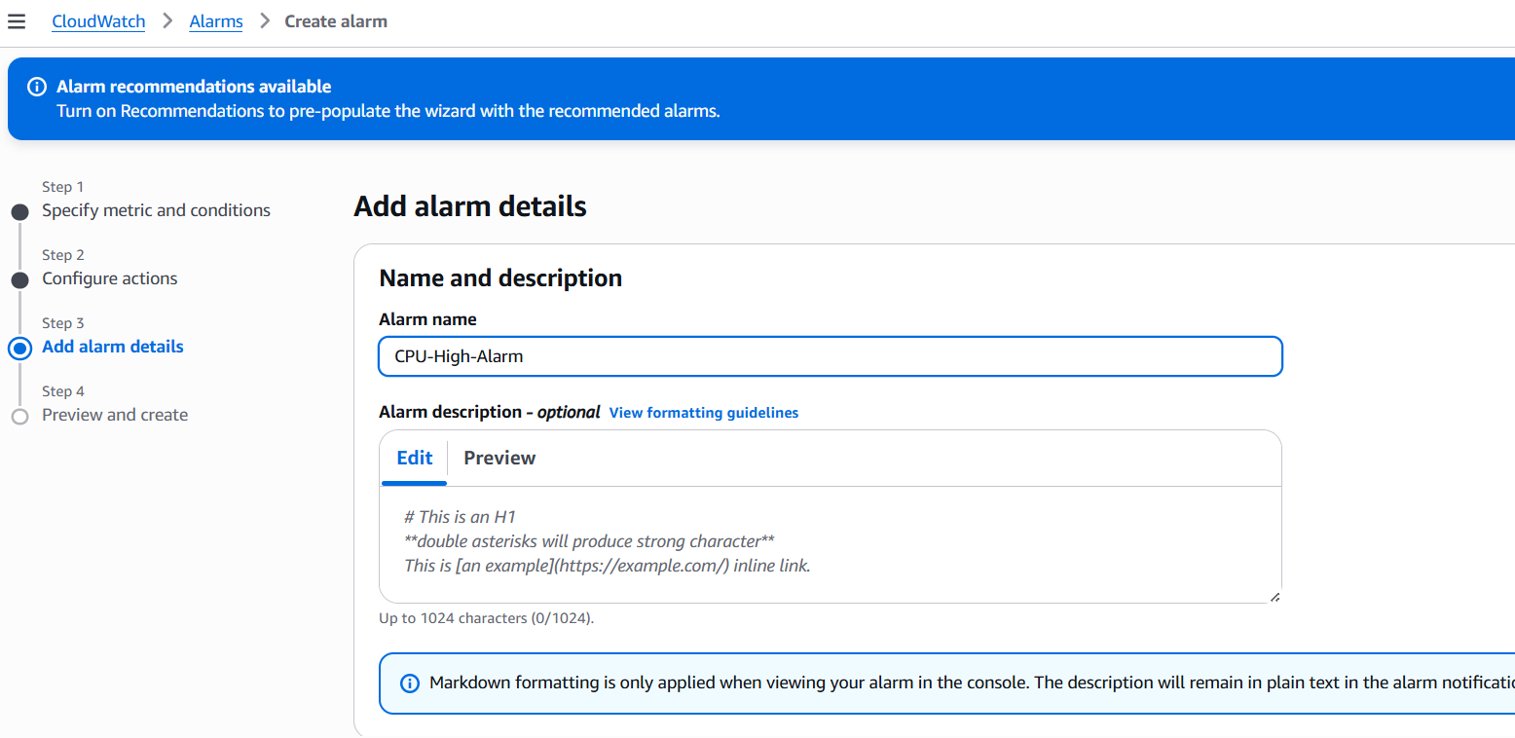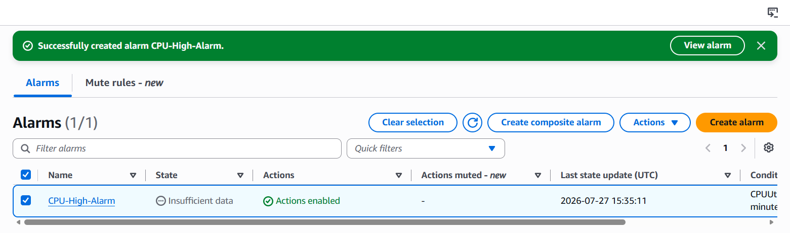Step 1 — Connect to EC2
From your local machine:
ssh -i your-key.pem ec2-user@YOUR_PUBLIC_IP
Replace:
· your-key.pem → your key file
· YOUR_PUBLIC_IP → EC2 public IP
Step 2 — Install stress Tool
For Amazon Linux:
sudo yum update -y sudo yum install stress -y 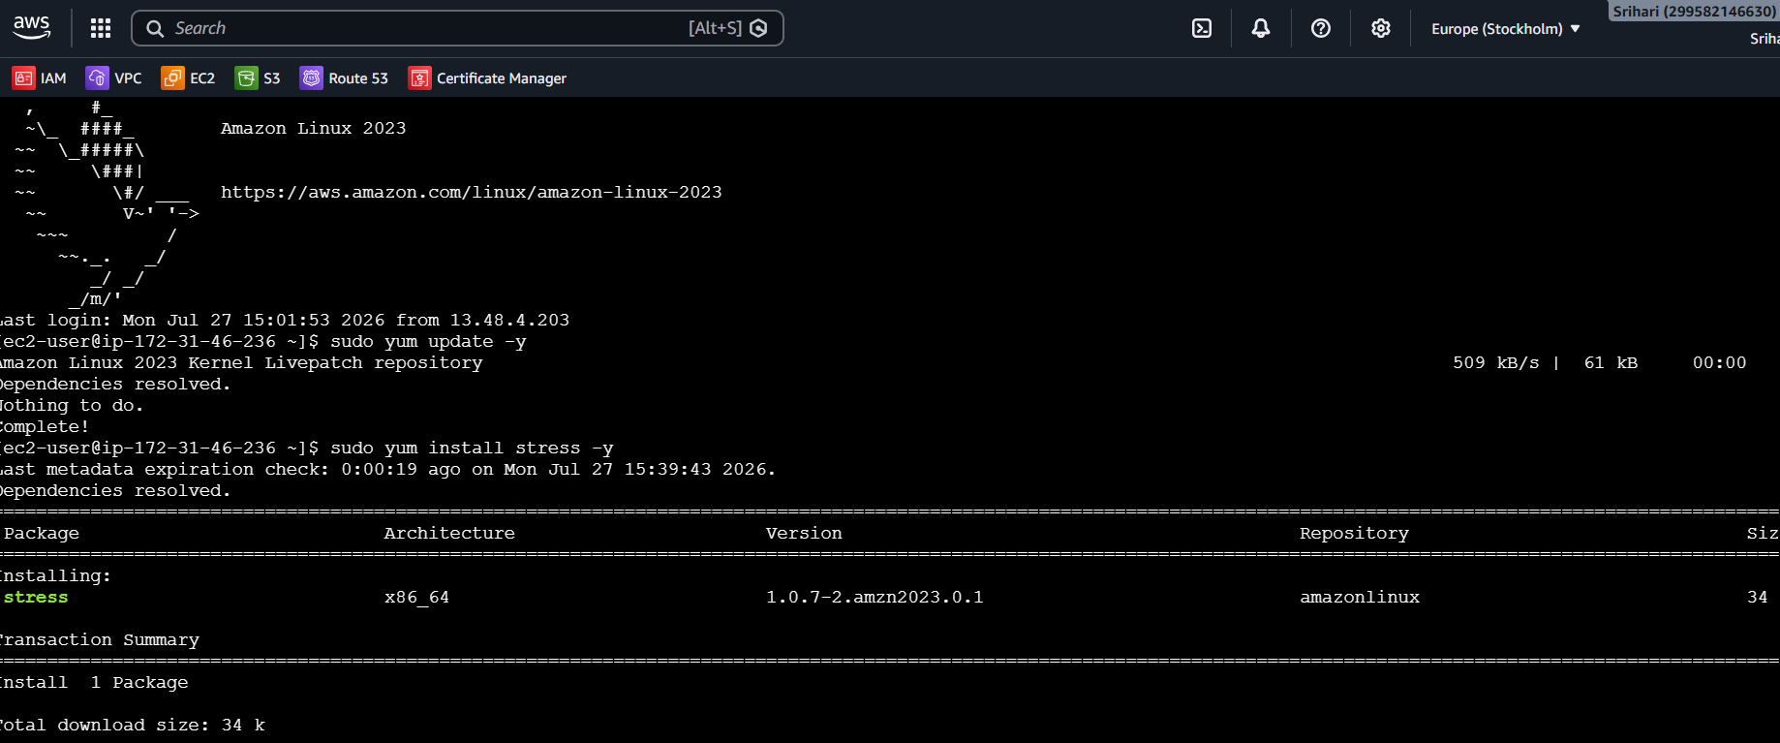
Step 3 — Increase CPU Load (Trigger Alarm)
For t2.micro / t3.micro:
stress --cpu 1 --timeout 300
or

After Running Command
1. Go to CloudWatch → Alarms
2. Wait 2–5 minutes
3. CPU should go above 70%
4. Alarm state → 🔴 IN ALARM
5. SNS Email should be received
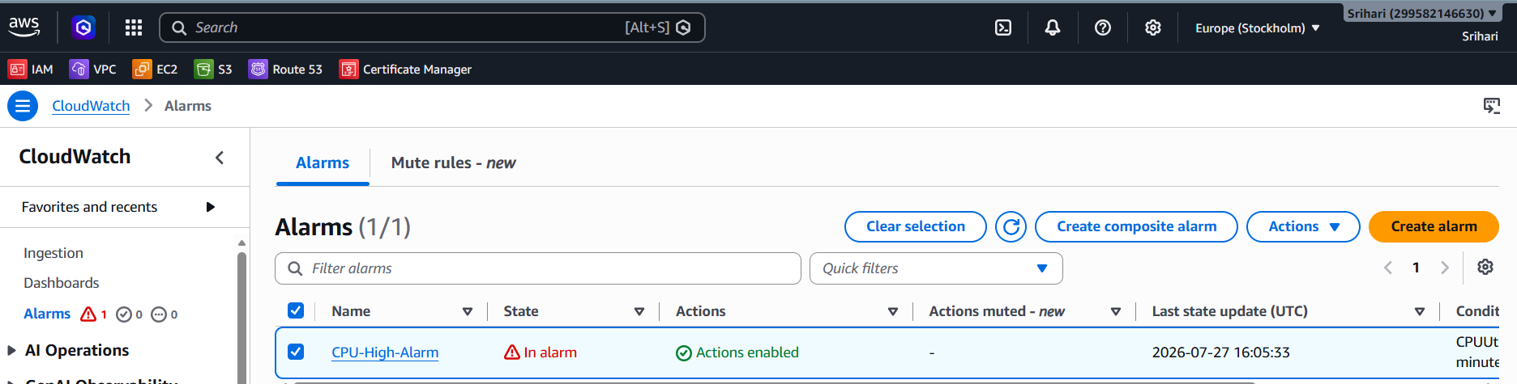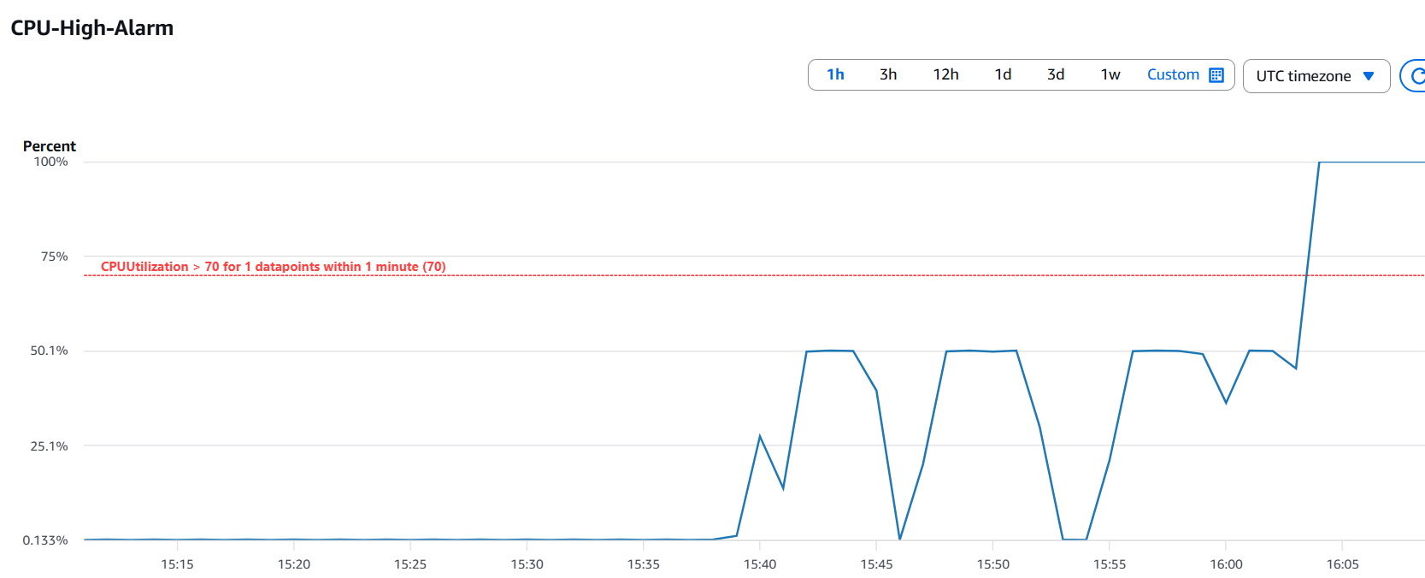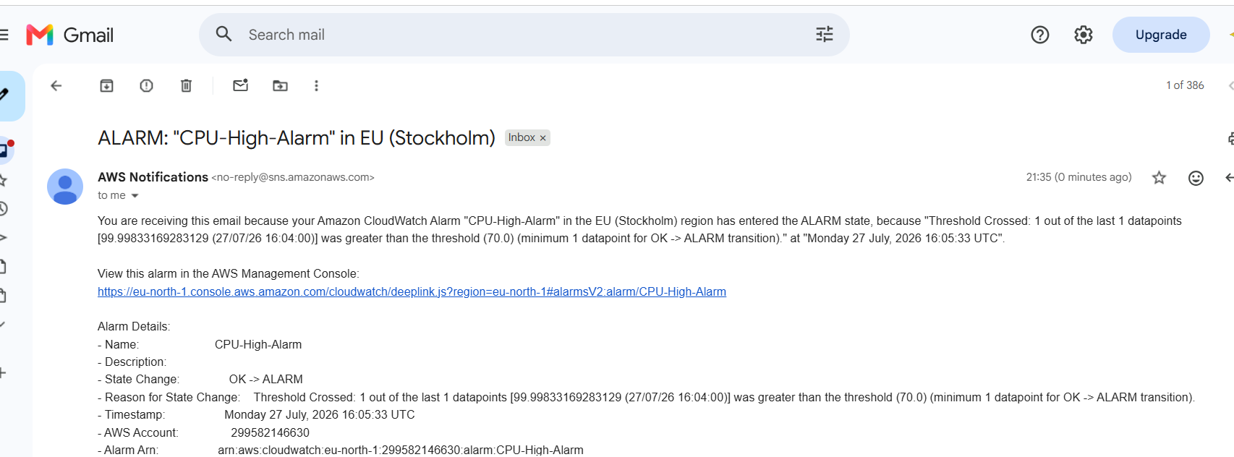

- Create a Dashboard and monitor the Tomcat service whether it is running or not and send the alert.
Default EC2 does NOT send service status.
We must install CloudWatch Agent.

STEP 1 — Install Tomcat (If Not Installed)
SSH into EC2:
ssh -i your-key.pem ec2-user@YOUR_PUBLIC_IP
Install Java:
sudo yum install java-1.8.0-openjdk -y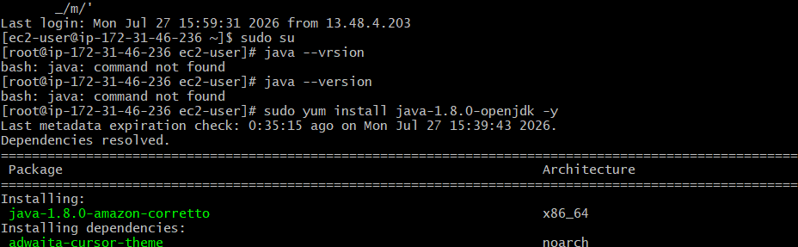
Install Tomcat:
sudo wget https://downloads.apache.org/tomcat/tomcat-10/v10.1.44/bin/apache-tomcat-10.1.44.tar.gz
sudo tar -xvzf apache-tomcat-10.1.44.tar.gz
sudo mv apache-tomcat-10.1.44 tomcat
cd /opt/tomcat/bin
sudo chmod +x *.sh
sudo ./startup.sh
Check status:
sudo systemctl status tomcat
It must show:
active (running) 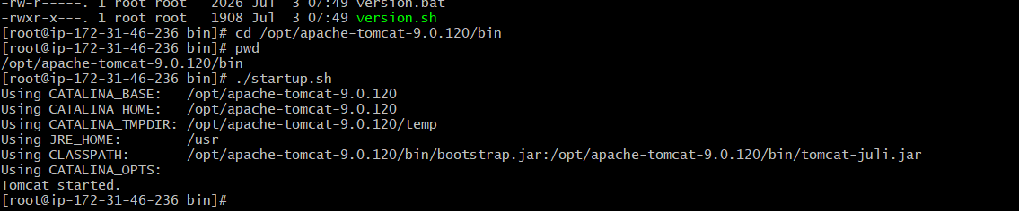
🔹 STEP 2 — Install CloudWatch Agent
sudo yum install amazon-cloudwatch-agent -y
🔹 STEP 3 — Attach IAM Role to EC2
Very Important
Go to:
EC2 → Instance → Actions → Security → Modify IAM Role
Attach role with policy:
CloudWatchAgentServerPolicy
If not available → create role:
IAM → Roles → Create role
Use case: EC2
Attach policy: CloudWatchAgentServerPolicy
Attach to EC2.
🔹 STEP 4 — Create CloudWatch Agent Config
Run:
sudo nano /opt/aws/amazon-cloudwatch-agent/bin/config.json
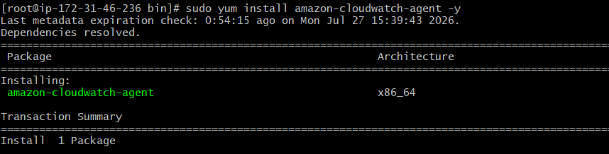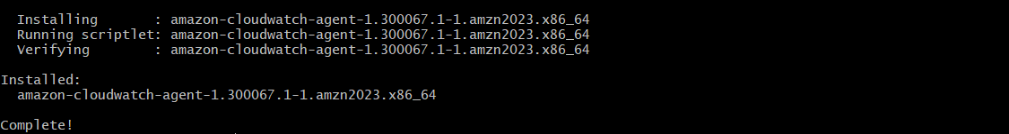 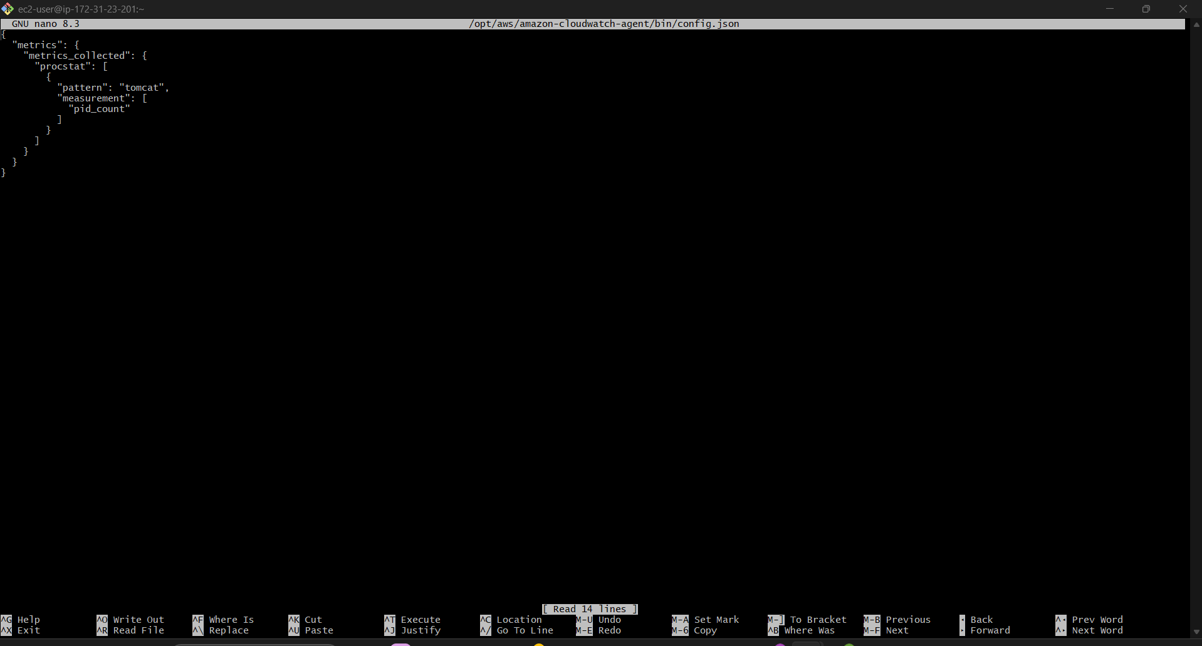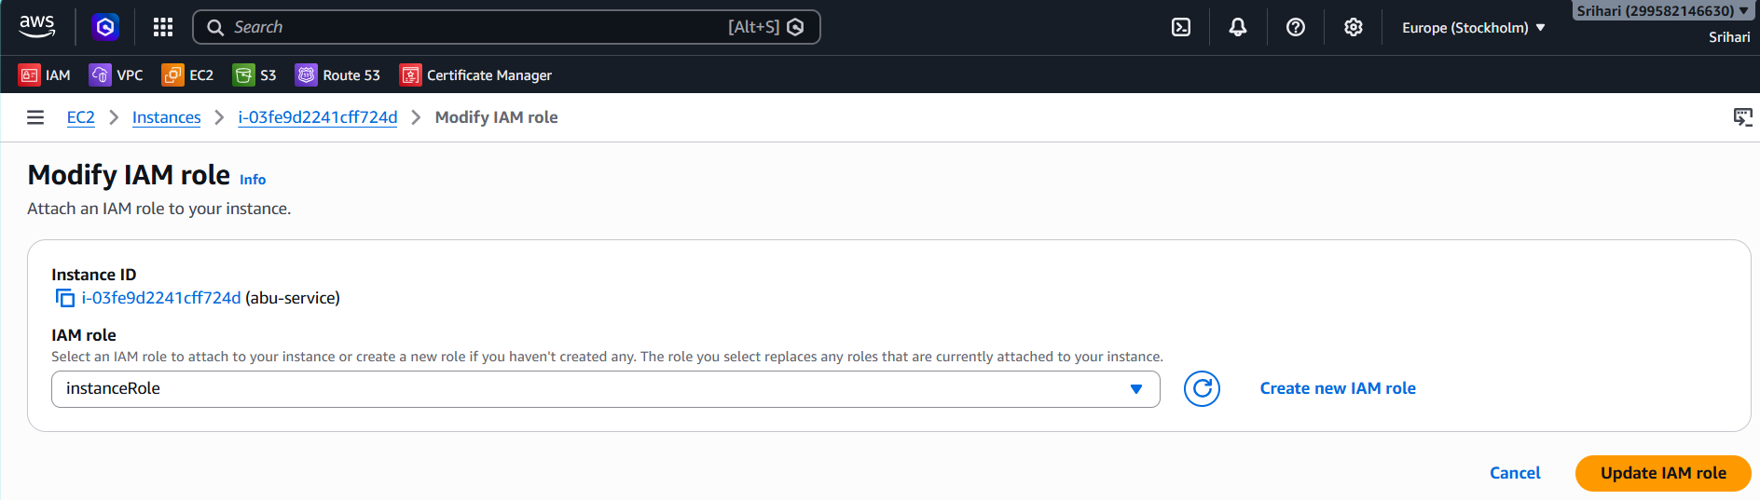 Step 5: Start Agent
sudo /opt/aws/amazon-cloudwatch-agent/bin/amazon-cloudwatch-agent-ctl \ -a fetch-config -m ec2 \ -c file:/opt/aws/amazon-cloudwatch-agent/bin/config.json -s
Check status:
sudo systemctl status amazon-cloudwatch-agent
Check status:
sudo systemctl status amazon-cloudwatch-agent

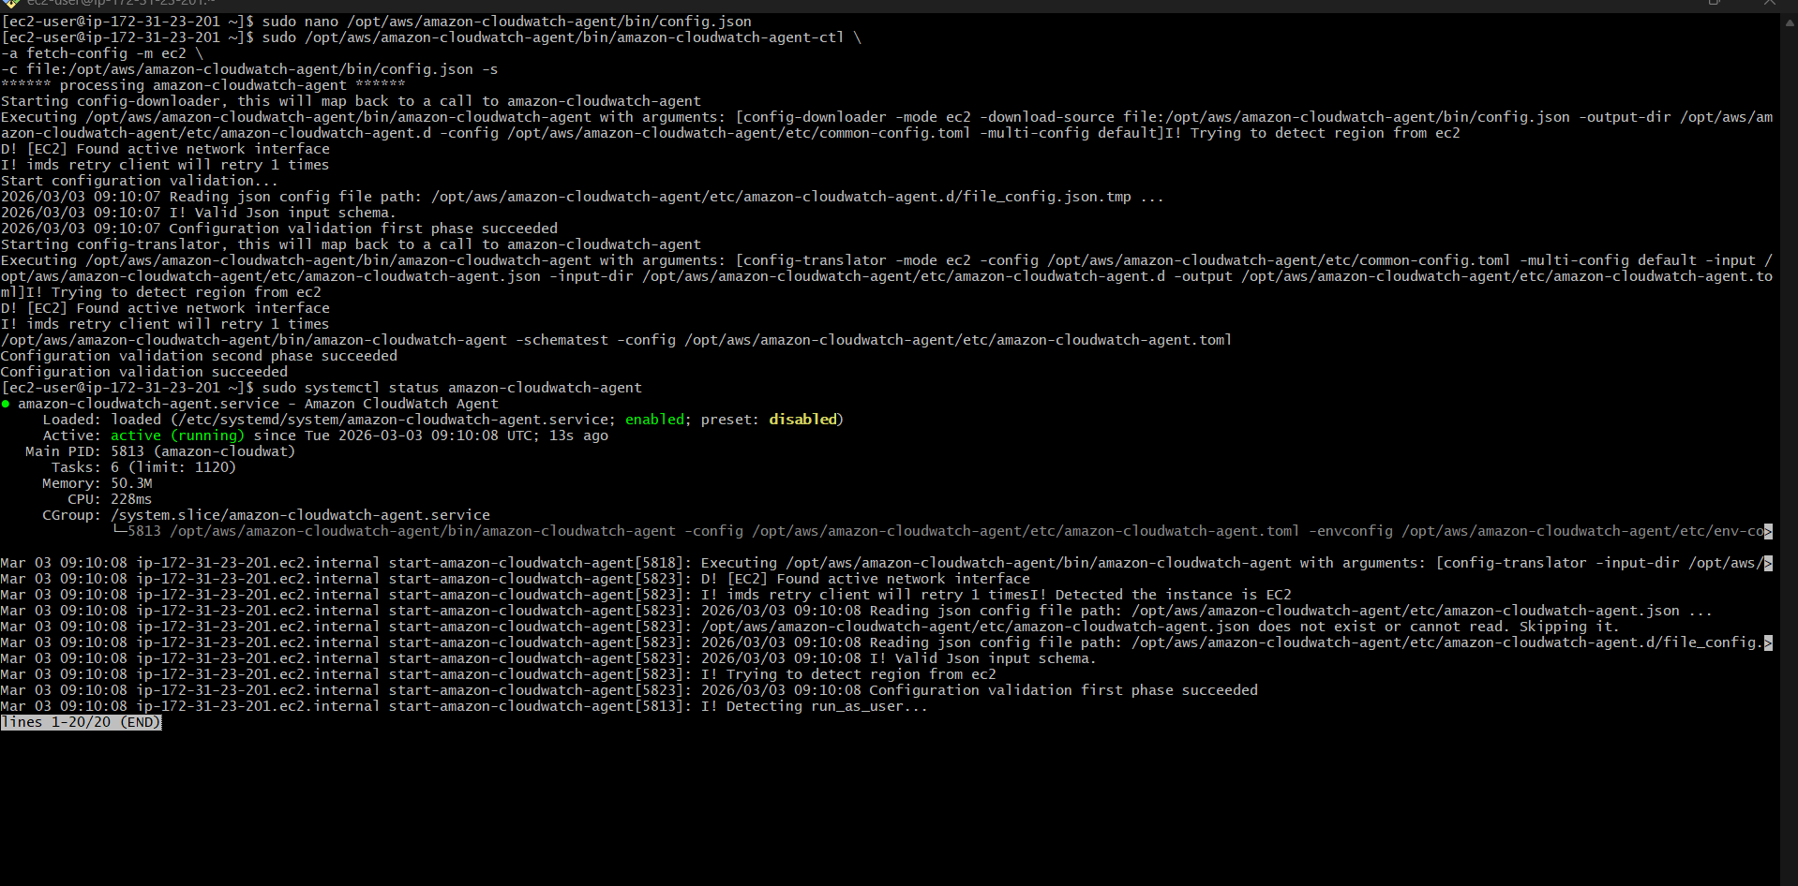
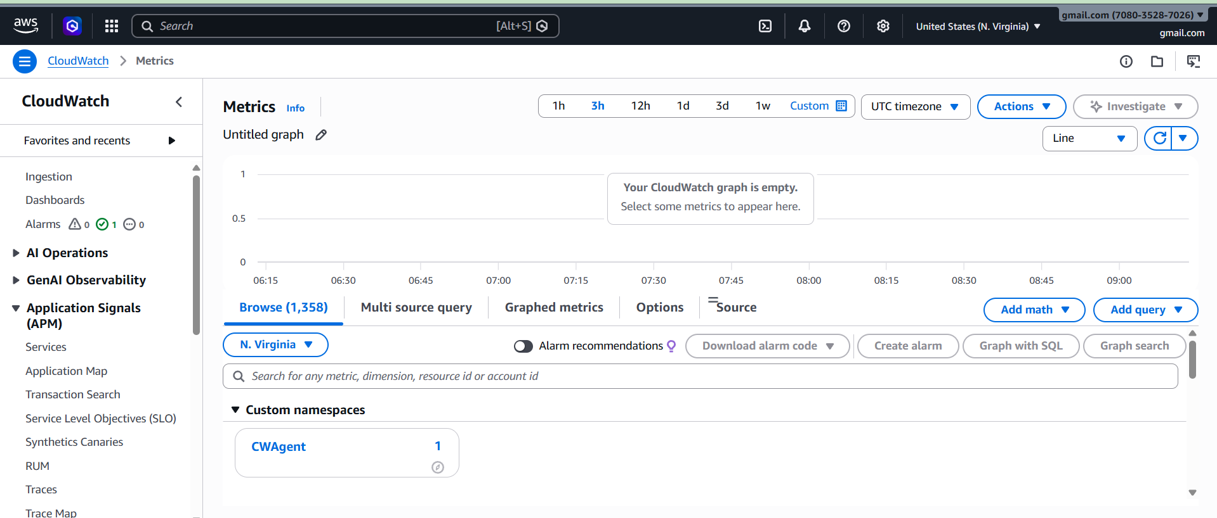

- Create a Dashboard and monitor the Nginx service to send the alert if Nginx is not running.
1: Install Nginx
sudo yum install nginx -y
Start the service:
sudo systemctl start nginx
Enable it after reboot:
sudo systemctl enable nginx
Verify:
sudo systemctl status nginx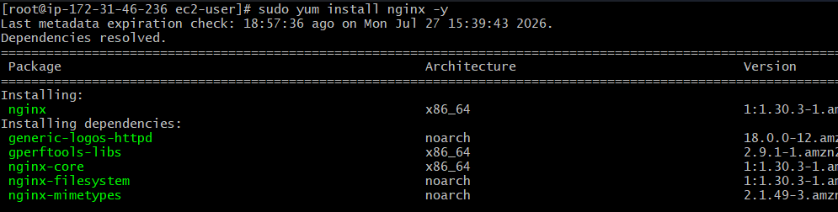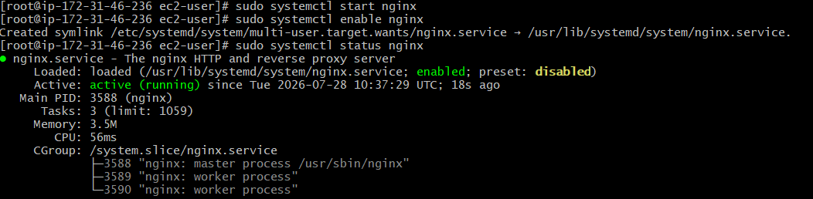
2:
Step 1: Open EC2 Console
- Go to AWS Console.
- Open EC2.
- Click Instances.
- Select your EC2 instance.
Step 2: Attach an IAM Role
- Click Actions.
- Select Security.
- Click Modify IAM Role.
You will see a screen like:
Actions
└── Security
└── Modify IAM Role
Step 3: Select an IAM Role
If you already have a role:
- Select the role from the IAM Role drop-down.
- Click Update IAM Role.
If you don't have one, create it first.
Create a New IAM Role
1. Open IAM
Go to:
AWS Console → IAM → Roles
2. Click Create Role
3. Trusted Entity
Choose:
AWS Service
Click Next.
4. Choose Use Case
Select:
EC2
Click Next.
5. Attach Permissions
Search for:
CloudWatchAgentServerPolicy
Select it.
For your Bash script that uses aws cloudwatch put-metric-data, you can also attach:
CloudWatchFullAccess
Next.
6. Name the Role
Example:
EC2-CloudWatch-Role
Click Create Role.
Step 4: Attach the Role to EC2
Go back to:
EC2 → Instances → Select Instance
Then:
Actions
↓
Security
↓
Modify IAM Role
Choose:
EC2-CloudWatch-Role
Click:
Update IAM Role
3: Create Bash Script
Create the file:
sudo vi /home/ec2-user/nginx_monitor.sh
Paste:
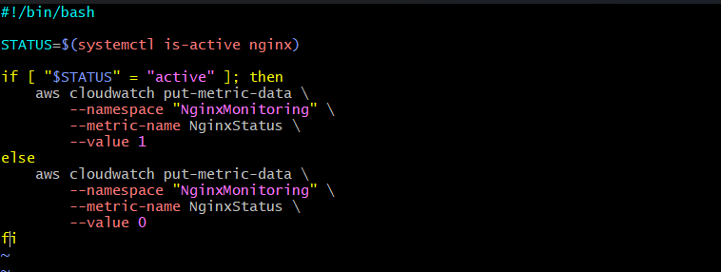
Save.
Step 4: Give Execute Permission
chmod +x /home/ec2-user/nginx_monitor.sh
Step 5: Test the Script
Run:
/home/ec2-user/nginx_monitor.sh
If there is no error, the metric is sent to CloudWatch.
Step 6: Create a Cron Job
Open cron:
crontab -e
Add:
* * * * * /home/ec2-user/nginx_monitor.sh
This executes the script every minute.
Verify:
crontab -l
Output:
* * * * * /home/ec2-user/nginx_monitor.sh
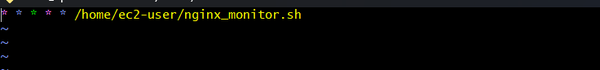
Step 7: Verify the Metric
- AWS Console
- CloudWatch
- Metrics
- Custom Namespaces
- NginxMonitoring
- Metric:
NginxStatus
Values:
1 = Running
0 = Stopped
Step 8: Create SNS Topic
- Open SNS
- Create Topic
- Name:
NginxAlert
Create an Email subscription and confirm it. 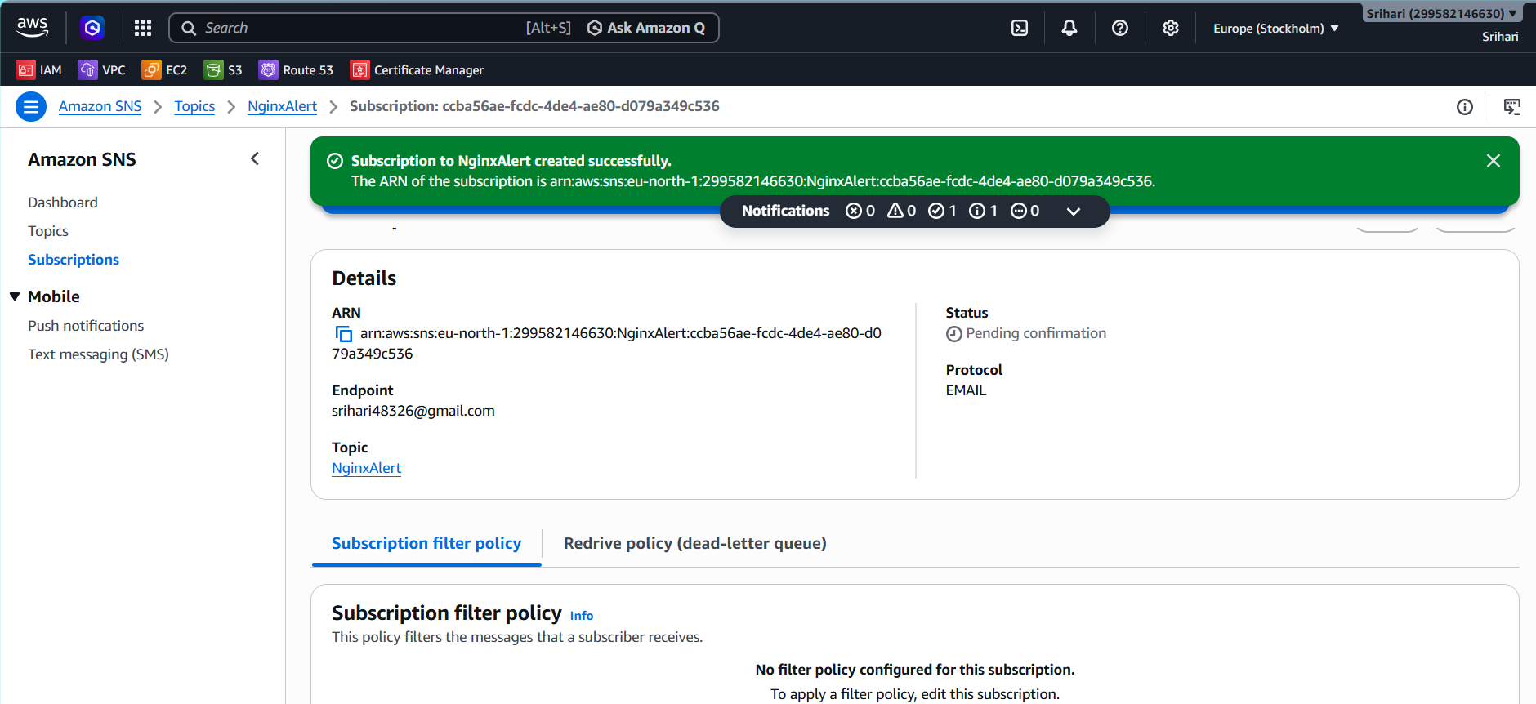
Step 9: Create CloudWatch Alarm
CloudWatch
↓
Alarms
↓
Create Alarm
↓
Select Metric
↓
Custom Namespace
↓
NginxMonitoring
↓
NginxStatus
Condition:
Whenever NginxStatus < 1
Notification:
Choose
NginxAlert
Finish.
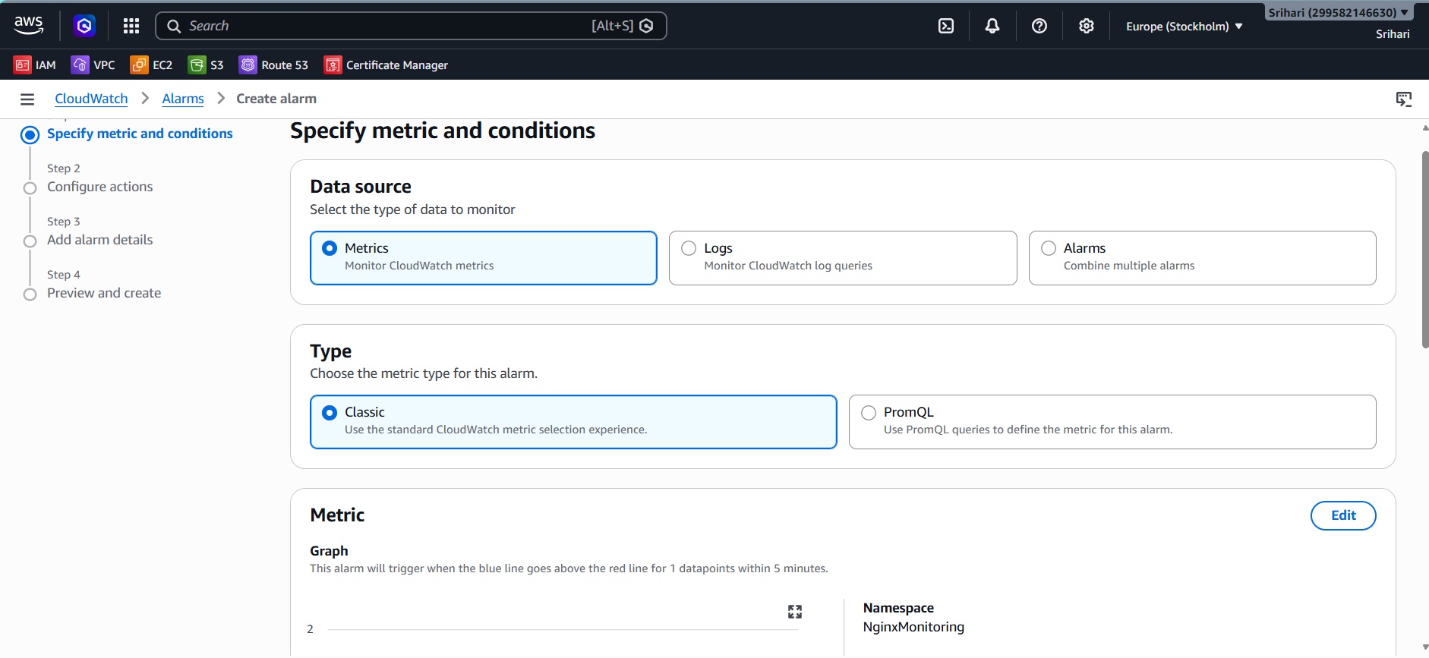
Step 10: Test
Stop nginx
sudo systemctl stop nginx
Wait about one minute.
The cron job sends:
Metric = 0
CloudWatch Alarm changes to
ALARM
SNS sends an email.
Restart nginx
sudo systemctl start nginx
Metric becomes
1
Alarm returns to OK. 